**Annotations**

When you’re using annotations, you should mark up the POJOs. The car entity is defined as shown here:

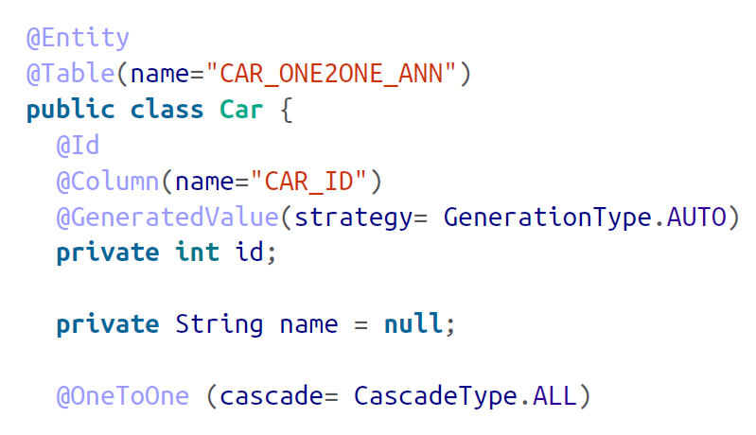

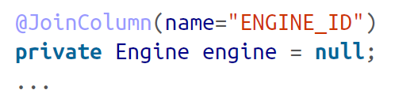

The Car class is annotated with an @Entity, making it eligible for persistence. The @Id annotation is declared on the *id* pointing to the CAR_ID from the table. We declare the one-to-one mapping using the @OneToOne annotation. As we have to join the car to the ENGINE table, the @JoinColumn is used on the ENGINE_ID column.

The Engine class is much simpler. Apart from the usual class-level declarations, such as the @Entity and @Table annotations, the relevant annotation is on the car field (@OneToOne):

